**Step 1**. Sign up a [Google account](https://accounts.google.com) if you don’t already have one. Otherwise, sign in your account.

**Step 2**. Go to [Python boot camp](https://drive.google.com/drive/folders/1YbaIz9J03-26tUp7P_mtVbESl9GWtpYE?usp=sharing), download the learning material. You get a .zip file.

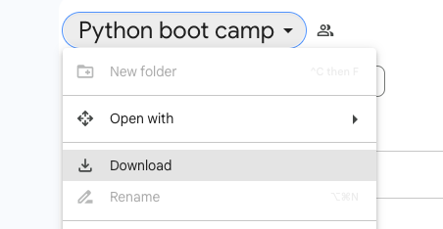

**Step 3**. Unzip the file. You get a folder called “Python boot camp”.

**Step 4**. Go to [My Drive](https://drive.google.com/drive/my-drive) on Google Drive, upload the folder.

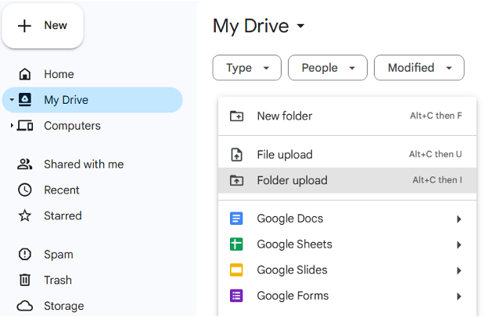

**Great! You are all set.**